Lab Report

Your Information
Your Name: Joshua Zimmerman-Gibson
Assignment Title: Create Visualizations in Tableau

Screenshots
Add Student ID and date
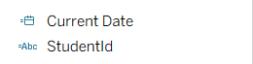
Download, Unzip, and Import the Instacart Dataset into Tableau
Import All CSV Files as a Single Data Source
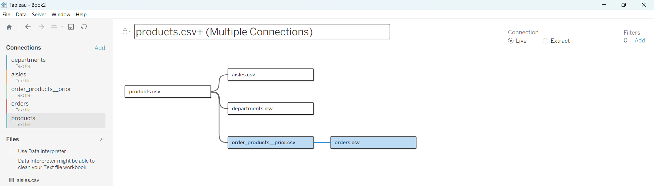
Establish Relationships Between Tables
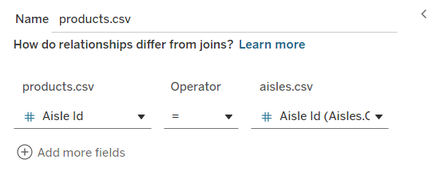
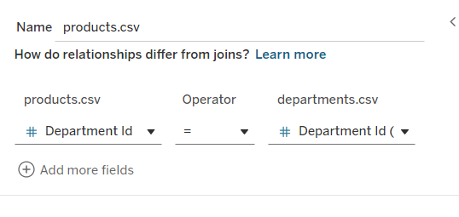
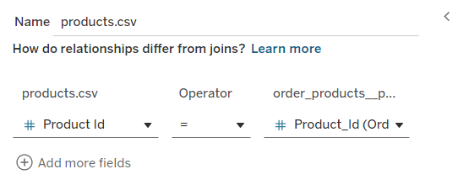
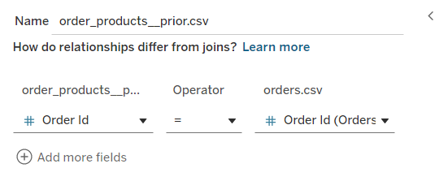
Line Chart — Median Days Since Prior Order by Hour of Day
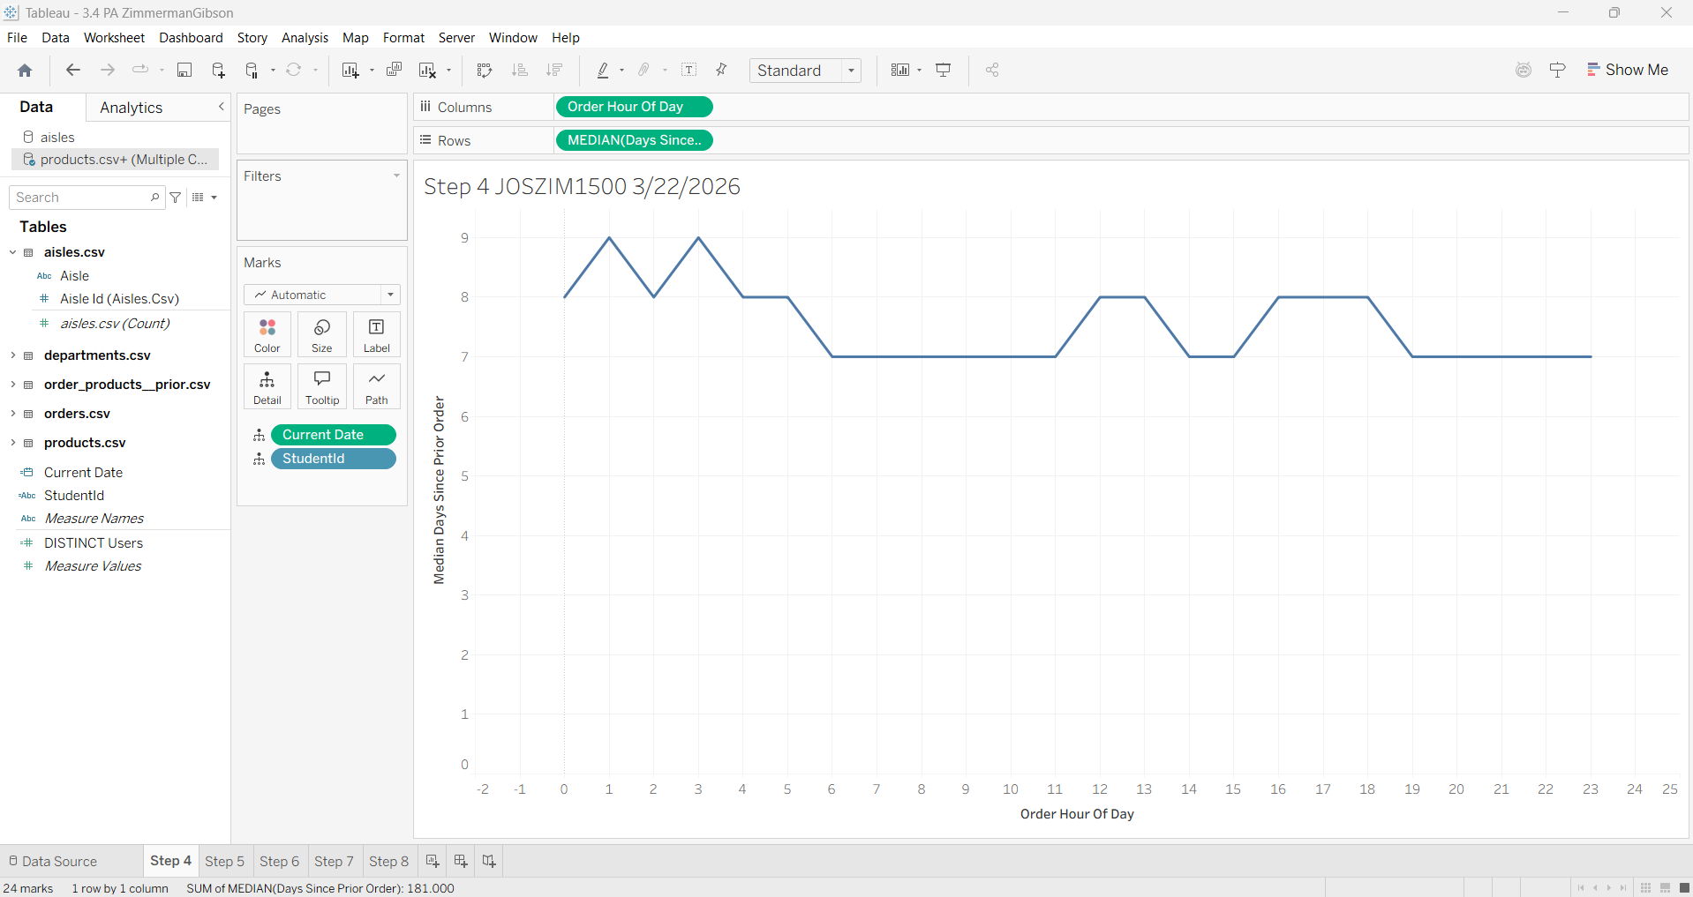
Bar Chart — Product Count by Department
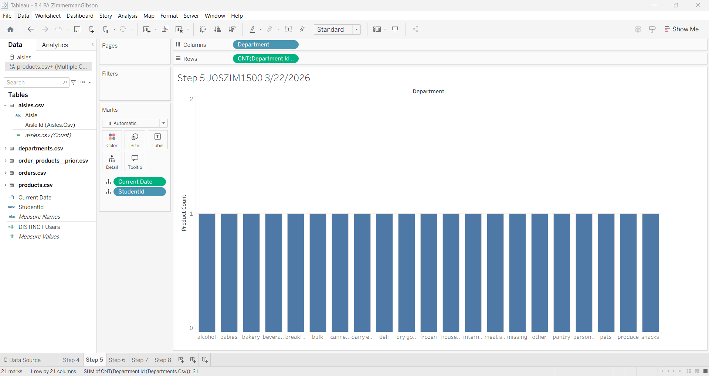
Dual-Axis Line Chart — Order Hour vs. Avg Days Since Prior Order + Sum of Reorders
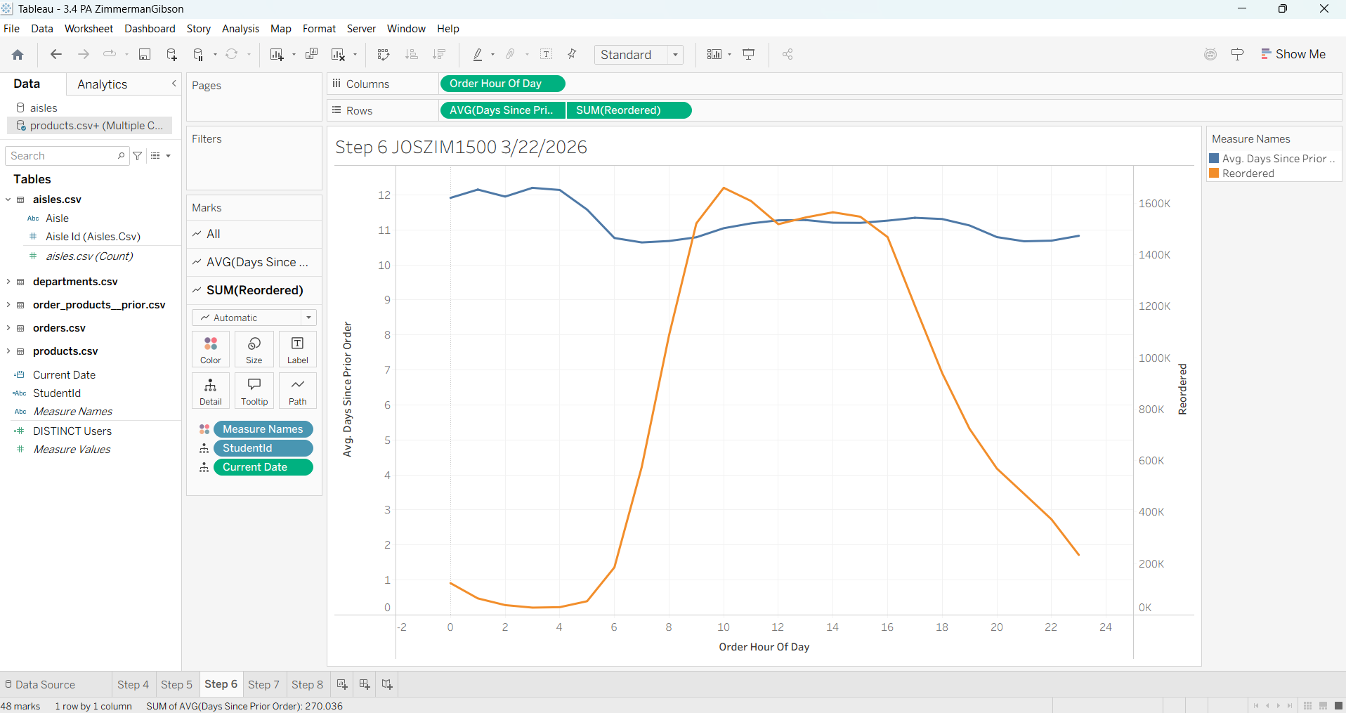
Heat Map — Count of Products by Department and Aisle
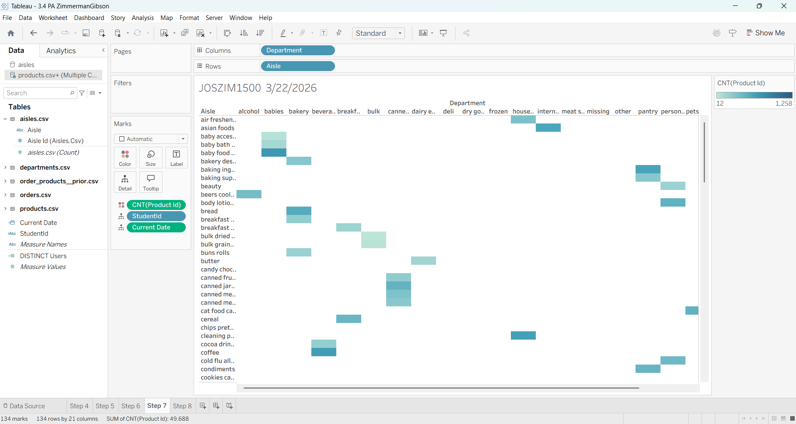
Box-and-Whisker Plot — Unique Count of Users by Department (Aisle as Detail)
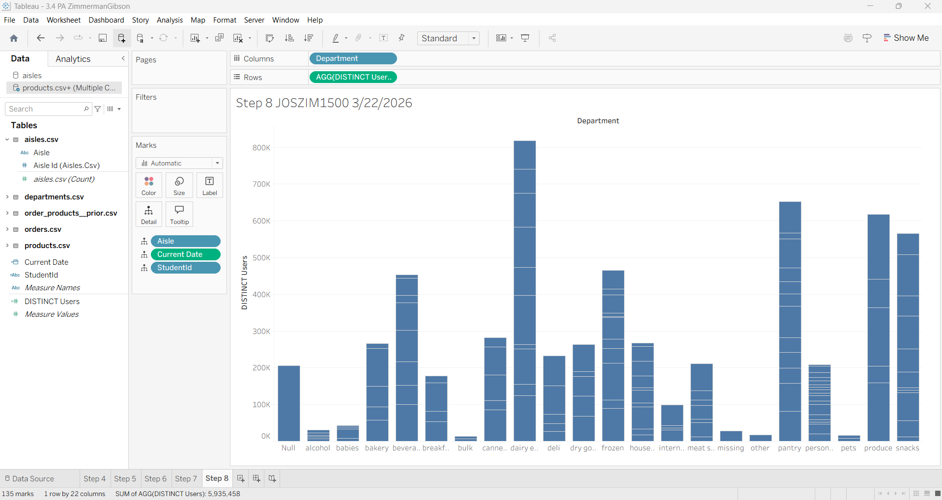

Questions
- How can you leverage this basket analysis to optimize product placement within the store, increase cross-selling opportunities, and enhance overall customer experience? Keep in mind this data comes from a digital shopping application where the user is not directly shopping in-store, and instead a proxy is collecting the order.
Product Placement

Items frequently bought together can be placed near each other in aisles, making it easier for shoppers to find complementary products.
If certain aisles see high co‑occurrence (e.g., snacks + beverages), the store could create small cross‑merchandise displays to encourage impulse purchases.

Cross‑Selling Opportunities

Basket analysis identifies items that customers tend to purchase together.
Stores can use this insight to offer bundles, coupons, or deals on these items (e.g., “Save $1 when buying pasta + sauce”).

Improving Customer Experience

When common product combinations are made easier to find in person, it reduces the customer’s time in the store and makes the experience smoother.
Online insights also help stores predict demand per department or time of day, meaning better stock levels and fewer out‑of‑stock situations.

Even though a proxy shopper fulfills digital orders, the underlying customer behavior patterns (what items people choose together and when they shop) are still meaningful.

- What key performance indicators (KPIs) can you identify in this dataset? How would you determine the effectiveness of recommendations or strategies based on the basket analysis, and what key performance indicators would you use to measure it?

Operational KPIs
- Order frequency (how often customers reorder)
- Days since prior order (good for spotting repeat customers)
- Reorder ratio (how often items get purchased again)
Product-Level KPIs
- Top departments by product count
- Most reordered products
- Peak order hours (helps with staffing and stocking)
Customer Behavior KPIs
- Average basket size (number of items per order)
- Cross-sell rate (how often paired items are bought together)
How to measure strategy effectiveness
- Increase in reorder rates
- Increase in units sold for the targeted product combinations
- Lift in basket size (are people buying more per trip?)
- Conversion rate for recommendations (did customers add suggested items?)
- Time-of-day engagement changes after promotions

- Pick one of the visualizations created. What are potential limitations or biases that could affect the usefulness of the insights gathered from this visualization?

Used the Bar Chart.
Limitations / Biases
- Uneven department sizes: Some departments have naturally more products than others, so the bar chart may overemphasize large departments even if they aren’t more important.
- No context for popularity: High product count doesn’t mean high customer demand, maybe a department has many items, but very few are purchased often.
- Missing time behavior: The bar chart shows volume but not when items are bought or how often.
- Bias from data source: Since this is digital shopping data, customers might choose items differently online than in-store (e.g., searching instead of browsing), making the insight slightly less accurate for physical placement.
These limitations mean visualization is useful but shouldn’t be the only factor for store layout decisions.

